**Black’s Mill Elementary School**

**Title 1 Parent and Family Engagement Plan for Shared Student Success**

**2022-2023**



Cindy Kinney, Principal

1860 Dawson Forest Road

Dawsonville, GA 30534

706-216-3300

[www.dawsoncountyschools.org](http://www.dawsoncountyschools.org)

Plan Revised August 1, 2022

**What Is It?**

Black’s Mill Elementary School is identified as a Title 1 school and offers the right of parents of children participating in activities funded by Title 1, Part A to be involved in every aspect of their child’s education. Title 1 is designed to support state and local school reform efforts tied to challenging state academic standards in order to reinforce and enhance efforts to improve teaching and learning for students. Title 1 programs must be based on effective means of improving student achievement and include strategies to support parental involvement. All Title 1 schools must jointly develop with all parents a written parental involvement plan.

**School Plan for**

**Shared Student Achievement**

**What is it?** This plan describes how Black’s Mill Elementary School (BMES) will provide opportunities to improve parent engagement to support student learning. BMES values the contributions and involvement of parents to establish an equal partnership for the common goal of improving student achievement. This plan describes the different ways that BMES will support parent engagement and how parents can help plan and participate in activities and events to promote student learning at school and at home.

**How is it developed and revised?** During the spring of each year, parents, students and teachers are invited to meetings and asked to complete surveys to gather suggestions and ideas to revise the current Parent Involvement Policy (PIP). Title I Committee members attend School Governance Council Meetings and PTO Executive Board Meetings to get input and suggestions for ways to increase parental involvement. An annual survey is sent to all parents of all students at BMES. Parent Comment Forms are distributed at all Title I events throughout the year in which parents are asked to record feedback for revisions for all Title I documents. Notifications are sent to parents via automated school phone message system, and PTO school newsletters alert parents that the PIP is in the revision process and input is requested from all parents. Parents are notified of the revision process of the PIP in a language the parents can understand to the extent practicable. In May, the Title I Committee revises the PIP for the following year using the feedback gathered throughout the year. Parents and staff are notified via automated phone message system, staff meetings, and during May events to review the revised PIP and submit comments and suggestions for changes. Parents may provide feedback on the PIP at anytime during the school year.

**Who is it for?** All students at BMES benefit from the Title I, Part A program, and their families are encouraged to fully participate in the opportunities described in this plan. BMES will provide full opportunity for the participation of parents with limited English, parents with disabilities, and parents of migratory children.

**How is it distributed?** At the beginning of the year, the plan sent home as well as posted on the BMES and district website. A parent session will be held in the Parent Resource Room during the fall to introduce parents to the newly revised plan. Parent Comment Forms will be distributed at this time and when returned, submitted to the Title I Committee. Parents can also retrieve a copy of the plan in the Parent Resource Room at anytime during the school year. Parents may request a hard copy through their child’s classroom teacher.

**Share Your Thoughts**

We want to hear from you! If you have any suggestions or if there is any part of this plan that you feel is not satisfactory with the students’ and the school’s goals for academic achievement, please provide us with your comments in the space provided and leave this form in the front office or feel free to send an email to Ashley Tobias at [atobias@dawson.k12.ga.us](mailto:atobias@dawson.k12.ga.us). You may also view this plan on the BMES website and download a Parent Comment Form. Please use this form to make suggestions and comments, and then return the form to your child’s classroom teacher. You may also provide feedback to the district on the school’s Title 1 Program by visiting the Dawson County School District website.

Name: (optional): _______________________

Telephone Number: (optional): ____________

Comments:

**Parent Resource Room**

The BMES Parent Resource Room is a valuable resource that allows parents to have access to books, study materials, and educational games to borrow and use at home. A computer is available for parents to explore educational sites to support student learning. All parents are invited to visit the Parent Resource Room during school hours and during Title 1 events to explore the different resources. A tour of the Parent Resource Room will take place at all Title 1 events. Resources will be explained and questions will be answered so that parents feel comfortable navigating through the materials while visiting the room. Many of the brochures available address ways to work with your child to boost achievement, home-to-school connections, and child development needs. If you need assistance in the Parent Resource Room, please contact Ashley Tobias [atobias@dawson.k12.ga.us](mailto:atobias@dawson.k12.ga.us).

**Title I Team**

**Please Detach and Return**

**__** Yes, I aminterested and wish to join the BMES Title 1 Team

__ Please contact me so I can learn more about the Title 1 Team and other volunteer opportunities at BMES

__ Please send me notifications and updates about upcoming meetings and updates

Name_____________________________

Phone #__________________________

Email Address: __________________________________

*\*Return to Ashley Tobias or your child’s homeroom teacher.*

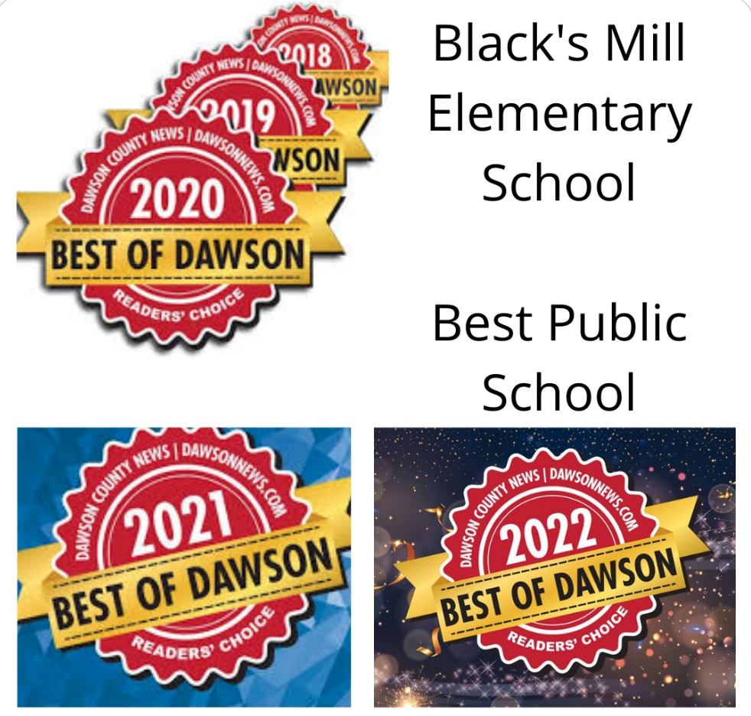

**Black’s Mill Elementary School is Branching Out!**

BMES will take the following measures to promote and support parents as an important foundation of the school in order to strengthen the school and reach our school goals. We will:

* Ensure that all information related to school and parent programs, meetings, and other activities is published in the parent’s native language to the greatest possible extent. Interpreters will be available at all Title I parent engagement sessions upon request.
* Conduct staff development activities that address the social emotional aspect of learning and how to build ties between parents and schools. Sessions will emphasize the importance of addressing the social/emotional aspect of children and families at different socio-economic levels and how to reach out to parents as equal partners and value the utility of their contributions.
* Work with the Bridge program to make sure that the transition from the Pre-K program is smooth. Upcoming Kindergartners will participate in Kindergarten Round Up with parents to answer questions and concerns that they may have about the upcoming year. Kindergarten teachers meet collaboratively with the BMES onsite Pre-K teachers to discuss ways to help transition students from the developmentally appropriate methods used in the Georgia State Pre-K curriculum to the GSE driven kindergarten classrooms.
* Work with Dawson County Middle Schools to provide informative field trips for fifth graders to ensure a smooth transition from elementary to middle school.
* Share information in English and Spanish at Title I sessions and conferences so parents can understand the school’s academic standards and assessments as well as the ways parents can monitor their child’s progress and work with educators. At conferences, teachers will interpret individual student assessment results and proficiency levels.
* Communicate with all families on a regular basis regarding school wide events and activities, through the automated phone system, social media, PTO newsletters, and flyers.
* Work with our parents to develop relevant trainings and helpful presentations to educate our staff on the importance of parent engagement.
* Provide necessary materials and handouts for parents at conferences, meetings and Title 1 parent-student engagement sessions to help parents work with their children to improve achievement.
* Offer meetings at various times and in different formats to meet the needs of parents.
* Offer transportation and child care services to prevent barriers from parent engagement.
* Provide parents with a description and explanation of the curriculum in use at the school.
* Involve parents in the decisions regarding how reserved funds are allotted for parent engagement activities.

**Let’s Get Together!**

Black’s Mill Elementary School will host the following events to support a partnership among the school, parents, and the community to improve students’ academic achievement. All parents and guardians are invited to attend!

* Black’s Mill’s Open House: August 3rd, 2022 4:00-6:00 pm
* Title 1 Annual Meeting  
  September 22, 2022
* Parent Teacher Conferences  
  October 19 & 20, 2022

March 9, 2023

* Technology Help for Parents   
  contact Ashley Tobias [atobias@dawson.k12.ga.us](mailto:atobias@dawson.k12.ga.us) or 706-216-3300 ext. 1246

*\*Look for additional events and activities sponsored by the school PTO!*

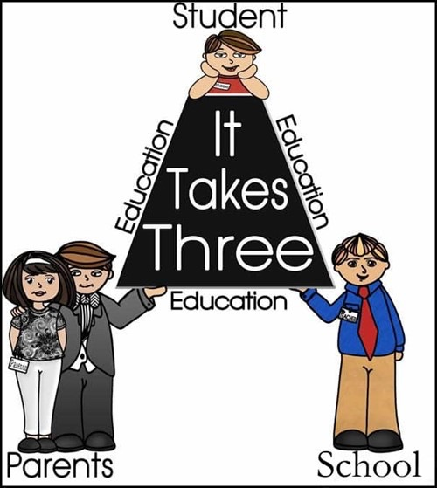

**School-Parent Compacts**

As part of this plan, BMES and our families will develop a School-Parent Compact, which is an agreement that parents, teachers, and students will develop that explains how parents and teachers will work together to make sure all BMES students reach grade level standards. The compact will be reviewed and updated annually based on feedback from parents, students and teachers through surveys, and various parent meetings including School Governance Council, parent engagement sessions, Student Council, and Parent-Teacher Organization (PTO). Feedback can be submitted anytime during the school year. The School-Parent Compact will be provided to each parent in the fall. Additional copies may be found on the school website and the Parent Resource Room. The School-Parent Compact will be discussed at conferences so that parents, students and teachers are able to review the commitment made to high achievement outlined in the School-Parent Compact. Individual student assessment results and interpretation of those results will be reviewed at parent-teacher conferences. Conferences shall provide opportunities for parents to formulate suggestions and to participate in decisions relating to the education of their children and the school will respond to any such suggestions as practicably as possible.

**District Goals**

**2022-2023**

1. Increase the percentage of students reading at or above grade level and scoring proficient or higher on state assessments in all core content areas by 3%.

2.Increase the percentage of IDEA students scoring at developing or higher in ELA, & MA and at/above grade level in RDG as measured by the state assessment by at least 3% at each school in order to decrease the achievement gap between IDEA and non-IDEA students.

3.Provide students with social and emotional learning support to improve their mental health well-being which directly impacts students’ ability to learn and grow academically.

**School Goals**

**2022-2023**

1. Increase the percentage of students reading at or above grade level and scoring proficient or higher on state assessments in all core content areas by 3%.

2.Increase the percentage of IDEA students scoring at developing or higher in ELA, & MA and at/above grade level in RDG as measured by the state assessment by at least 3% at each school in order to decrease the achievement gap between IDEA and non-IDEA students.

3.Provide students with social and emotional learning support to improve their mental health well-being which directly impacts students’ ability to learn and grow academically.

**Parental Engagement**

Black’s Mill Elementary School believes that parental and family engagement means participation of parents and families in regular and meaningful communication involving student academic learning and other school activities, ensuring:

* That parents and families play an integral role in assisting their child’s learning.
* That parents and families are encouraged to be actively involved in their child’s education at school.
* That parents and families are full partners in their child’s education and are included, as appropriate, in decision-making and on advisory committees to assist in the education of their child.
* The carrying out of other activities as described in this plan.

BMES is committed to involving our parents and families in the planning, review, and improvement of Title 1 programs, including the school Parent and Family Engagement Plan (PEP) and the Title 1 School Improvement Plan (SIP) by inviting all parents to serve on the Title 1 Committee.

Parents and families also have opportunities to share ideas and ways to involve other stakeholders in order to build partnerships with school, families and the community through feedback forms that can be found on our school website, and the Parent Resource Room. Parents can also submit their ideas or suggestions for the PEP at any school activities or meetings, as well as through our parent surveys. If you would like to request opportunities to meet or learn about more volunteer opportunities or school committees or teams, please contact Ashley Tobias via email at [atobias@dawson.k12.ga.us](mailto:atobias@dawson.k12.ga.us) or by phone at

(706) 216 – 3300 ext. 1246.